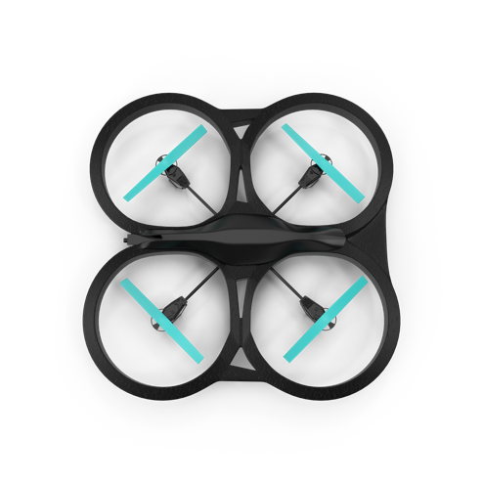

Marketing campaign research

Originally, we had just planned to do the phase one marketing campaign research, which centered on focus groups for feedback on packaging for previous versions. But what came out of those focus groups sent us in a new direction and so, our phase two research is the primary data and research information on which our marketing campaign planning is focused.

What stood out emphatically in our initial research, and was shown in the accompanying marketing deck, was that better than 90 percent of free responses (those in which the respondent is not given choices, but puts the response in their own words) were emotion-based. Their reactions to packaging were very personal. And so, we added research phase two to explore emotional responses to both our past packaging and current competitive packaging. *This second phase of research is the one driving our design direction.*

***N.B:*** This image of multiple people/emotions is a great one we can pull from for other content we’re creating for internal use, to reinforce the importance of emotional connection to this project. Crop to grab just the images you want (in fact, the full image has more people options). The full size image is in the project’s SharePoint image library if you need high resolution.

* What features of a package drive emotional response?
* What package elements elicit strong, positive emotional responses?
* What package elements elicit strong, negative emotional responses?